

**Name: Talha Usman  
Class: SU92-BSAIM-F24-064  
Subject: AI-Lab**

**Movie Budget Analysis**

**Introduction:**

This project is a simple Python program that calculates the **average budget** of a list of movies and then identifies which movies have a **budget higher than the average**.  
It also shows by how much each high-budget movie exceeds the average budget.

**Program Flow:**

1. A list of movies is created where each movie is stored as a **tuple** containing its name and budget.
2. The program asks the user if they want to add more movies.
   * If yes, it takes the number of movies to add.
   * Then it accepts movie name and budget inputs and appends them to the list.
3. A **for loop** is used to calculate the **total budget** of all movies.
4. The **average budget** is calculated by dividing the total budget by the number of movies.
5. The program loops through the movies list again and compares each movie's budget with the average
   * If a movie's budget is higher, it calculates how much higher and prints the result.
6. Finally, it prints the **number of movies** that have a budget greater than the average.

**Flow of the code:**

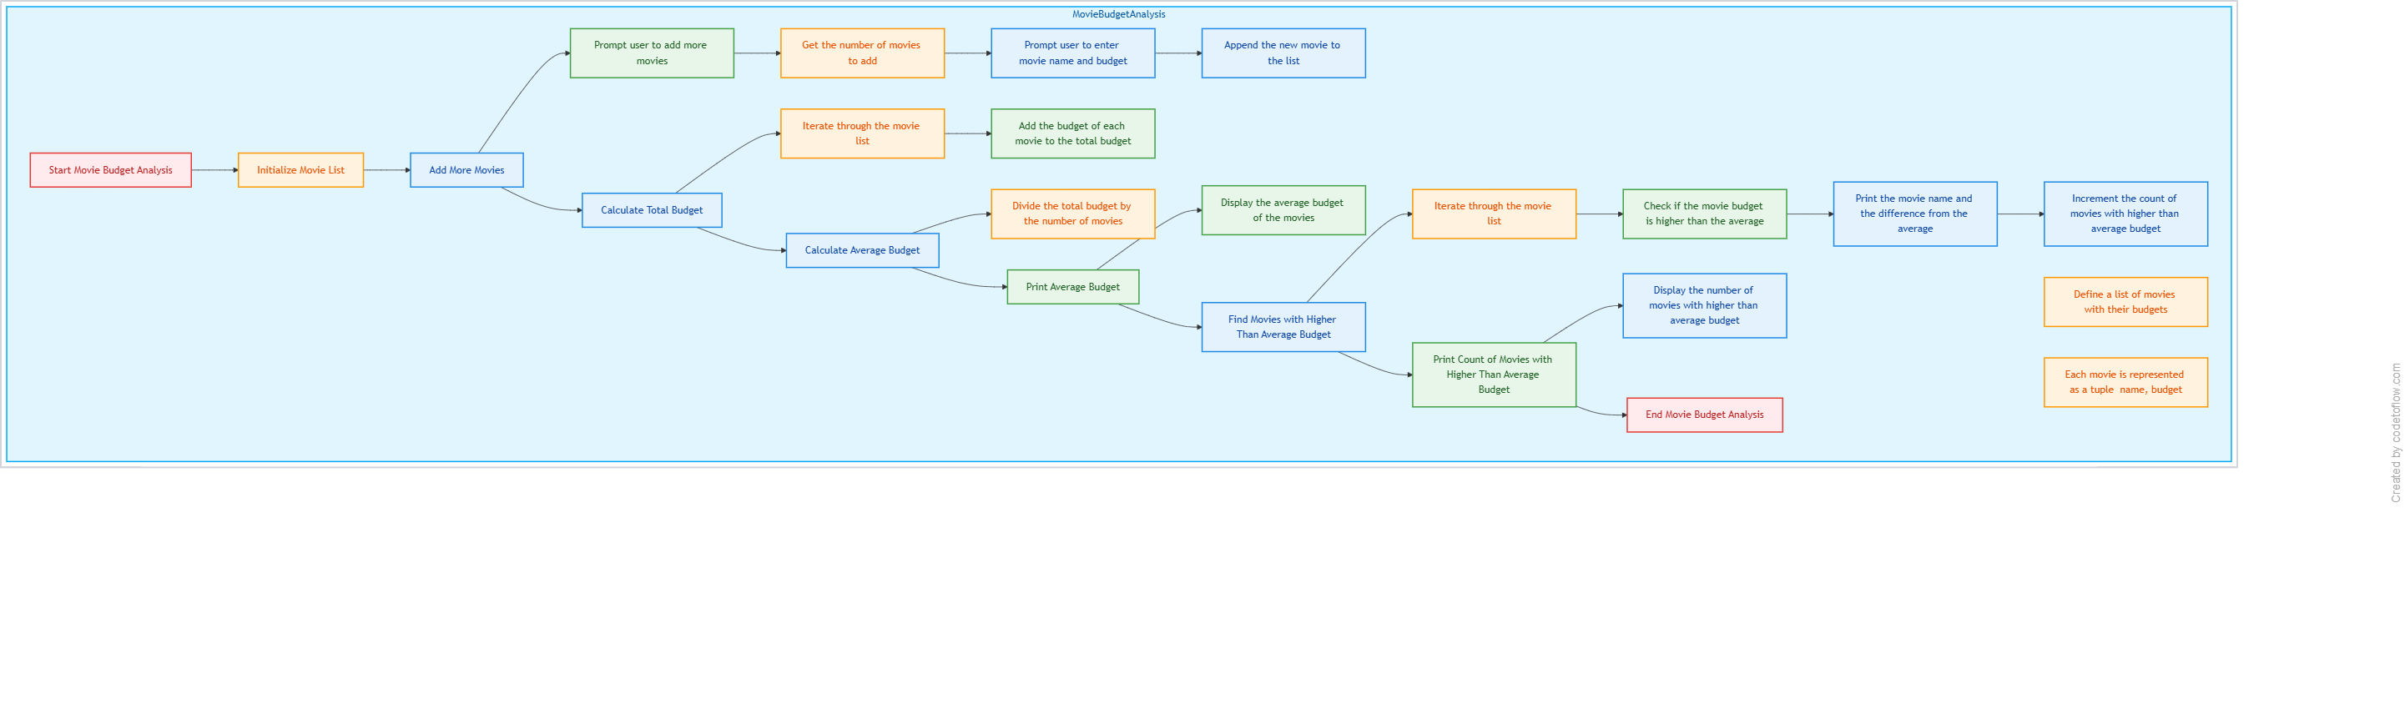

**Output of the code:**

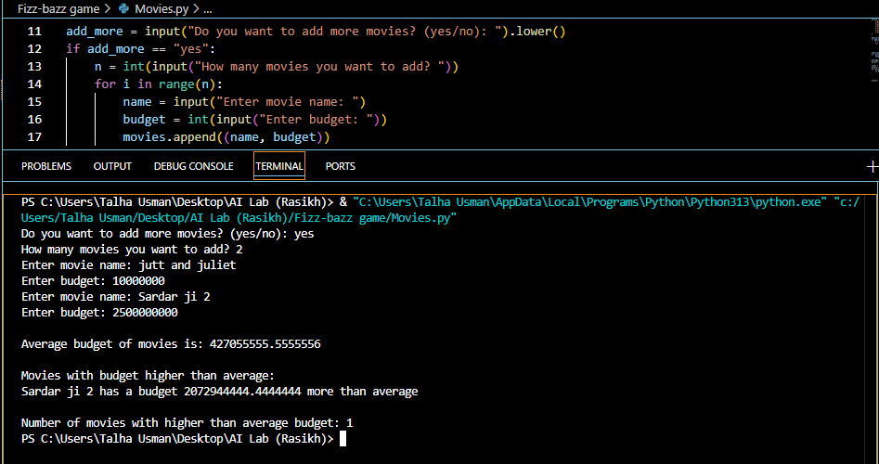

**Conclusion:**

This program demonstrates the use of **lists, tuples, loops, and conditional statements** in Python.  
It shows how to collect **user input dynamically**, perform **arithmetic operations**, and display results clearly.  
It is a great **beginner-level program** for practicing **list manipulation** and **average calculations**.